**Azure VNet Peering**

**Naman Moolri CEQ-525**

**Introduction:**

**Azure Virtual Network** is used for the **Virtual Network Peering,** empowers users to flawlessly communicate with virtual networks in Azure. VNet Peering in Azure allows the traffic of one virtual network to communicate to another virtual network. This is basically used for database failover, disaster recovery, or cross-region data replication. VPN gateways are used in an encrypted connection in the region but VNet Peering provides connection sharing in different regions.

**Types Of VNet Peering:**

**Default VNet Peering**: It empowers the connectivity between various VNets within the same Azure region.

**Global VNet Peering:** It allows Virtual networks to connect across different Azure regions. It provides private peering with low latency and high bandwidth in Azure backbone infrastructure.

**Steps to do VNet Peering:**

1. **First, we will create a 2 VNets.**

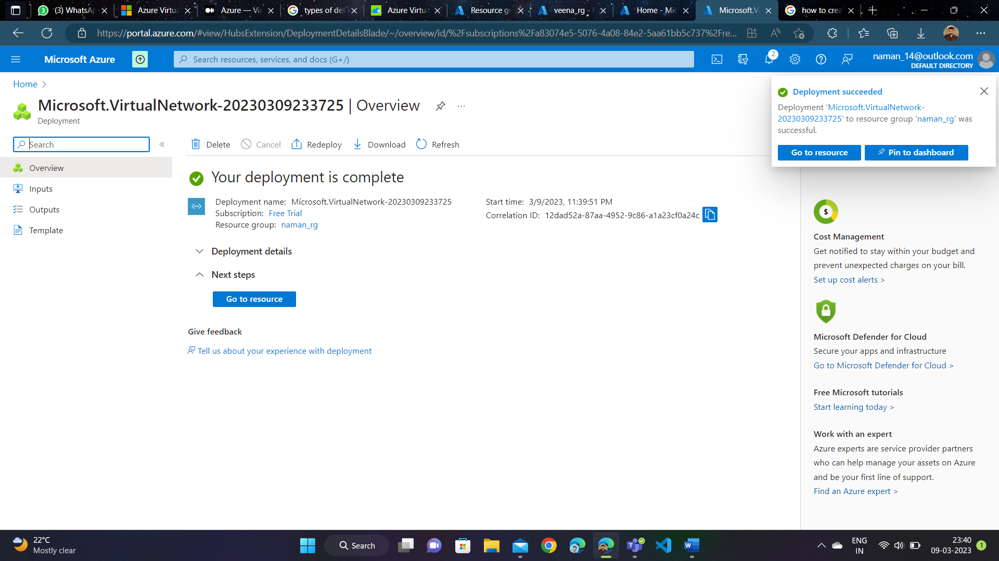

1. **Then, we will create a VM each in both Vnets. After the successful creation of VMs, connect them to RDP.**

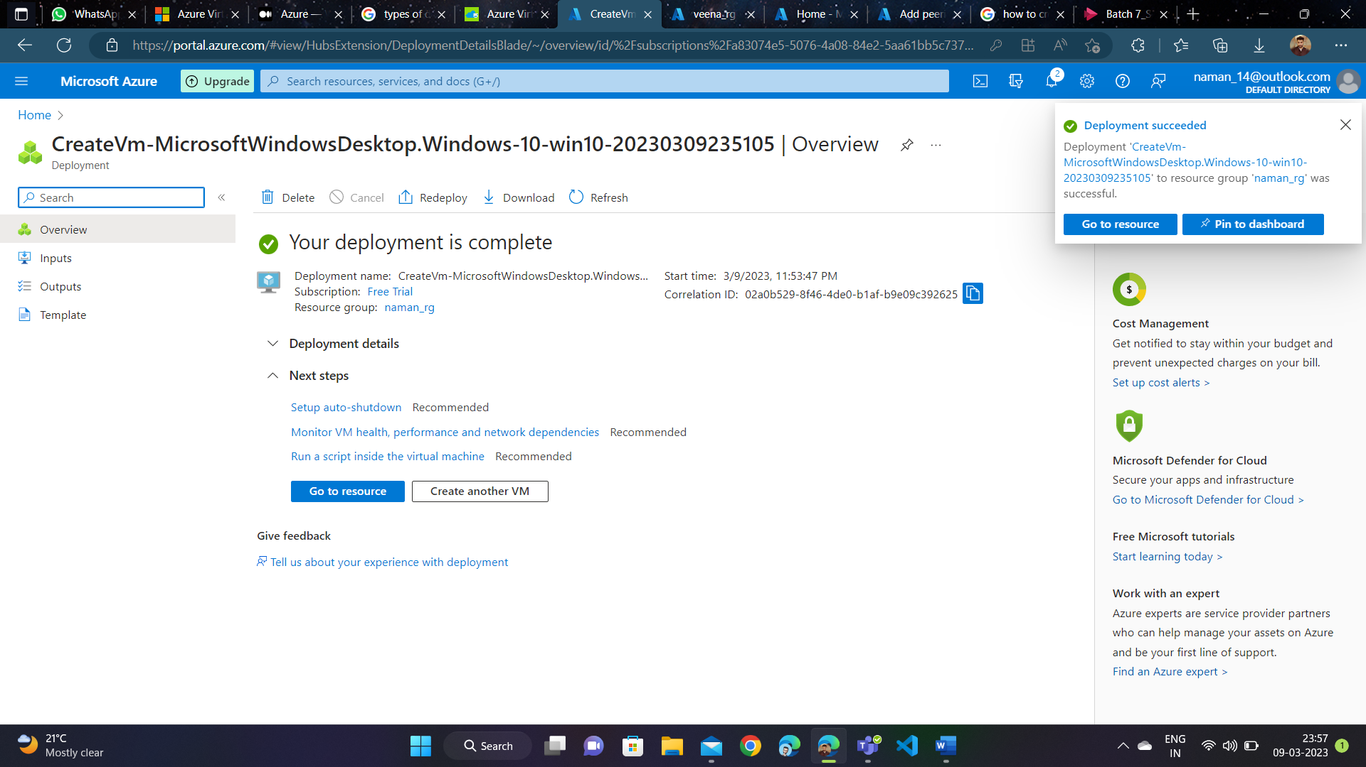

1. **Now, open any one VNet. Go to the Peerings section. Add Peering.**

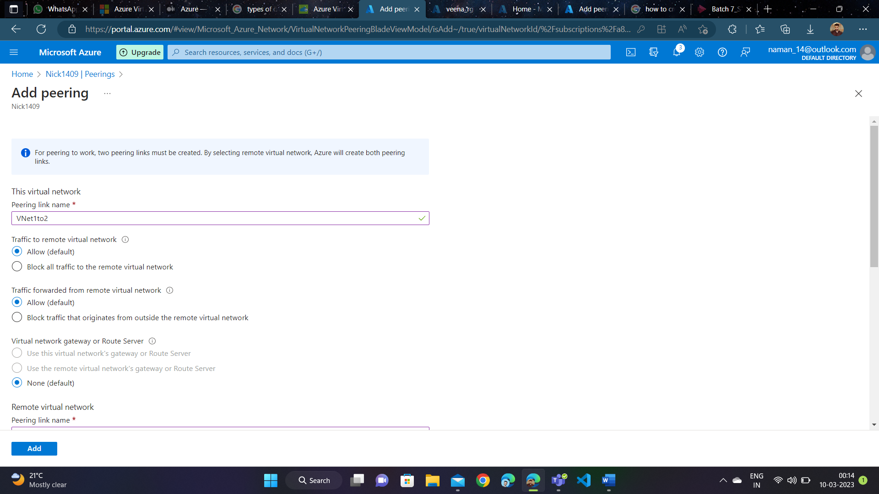

1. **Both the VNets are peered.**

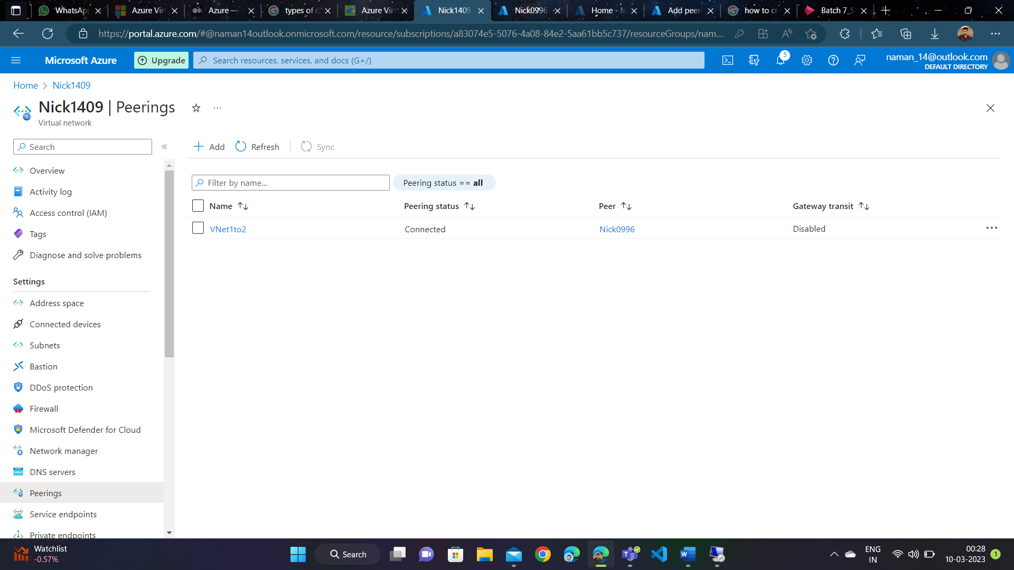

1. **Now, go to both VMs and disable their respective firewalls just to ensure that it doesn’t throw a ‘Request Time Out Error’ in CMD.**

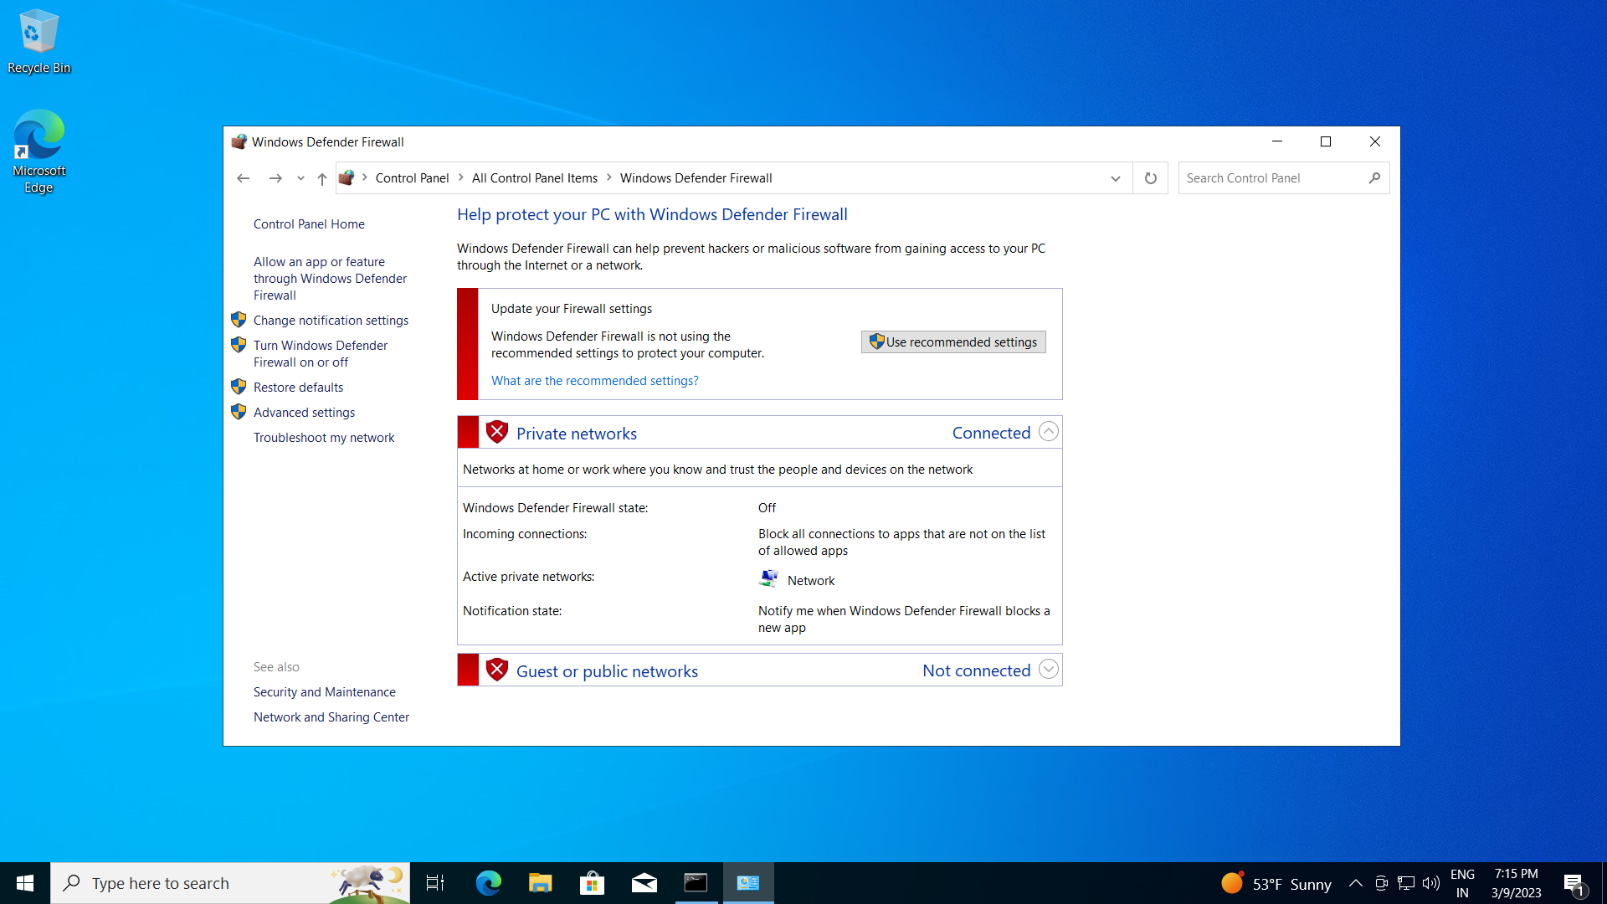

1. **Now, go to 2nd VM, open CMD, type a command ping {Private IP of 1st VM}. Press Enter. Similarly, go to 1st VM, open CMD, type a command ping {Private IP of 2nd VM}.**

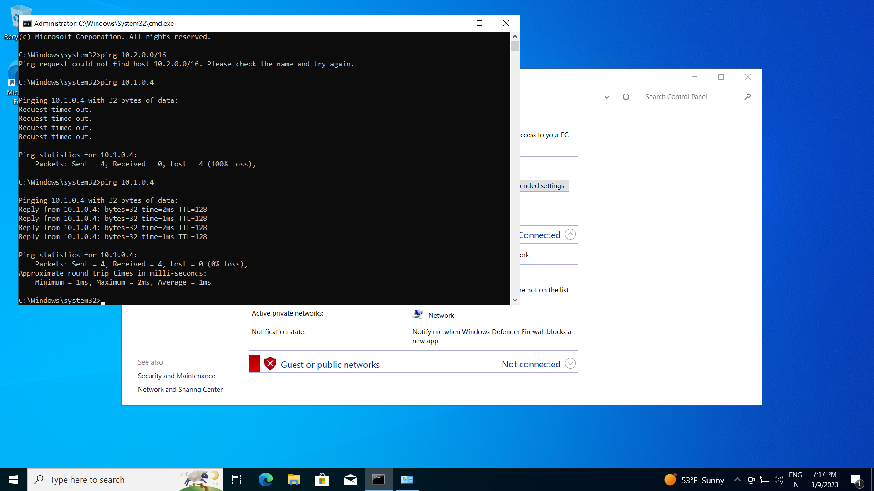

1. **This is how VNet Peering is done.**